AATC_GPIO
Introduction
The AATC_GPIO module is used to for the GPIO functions such as waiting for switches and controlling LEDs as well as providing a Thread Controller system to manage a number of sub threads via a single command queue.
The GPIO functions can be used to control the behaviour of the drone as well as alert those in the vicinity of the drone of it’s current state i.e. waiting for flight, disabled etc. The current setup for the GPIO behaviour of the drone is as follows:
Waiting for flight – 5 seconds green on, 1 second green off, repeat
In Flight – green flashing at 0.5Hz
Login error – red blink at 1Hz 10 times
Exception – red blink at 3Hz 30 times
Waiting for switch – Blink at 1/(2*Wait_Time) Hz until button is pressed.

The Thread Controller system is used to manage a number of threads automatically, being able to communicate with the thread controller via a command queue in order to send the controller or the subthreads commands. This communication is one way only per default, however it would be possible to pass return queues to the subthreads to allow return messages to be sent. This one way communication design choice was taken as per default there is only one command queue, if one also created a single return queue which multiple threads may have access to there is the chance that the data will be accepted by the wrong thread, leading to an unreliable system. In comparison the version where the return queues are passed as arguments the subthreads can return data to a specific return queue if needed , with the option of creating more return queues for specific threads if needed. An example of the returning queue being passed as an argument is found in the Hedabot module, the Input_Sorters and Command_Executors being able to return messages to the main thread via a return queue so that the contained messages may be sent from the main thread.

Import
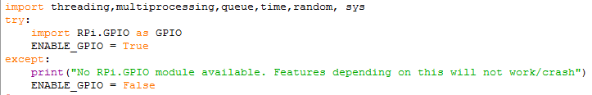
The GPIO module requires a number of modules. The threading module is required for creating threads and the multiprocessing module is required for multiple processes. The queue module is required for communicating between these threads via queues. The time module is required for time management, the random module is required for pattern generation. The sys module is optionally required for checking if the GPIO module is imported, however this does not seem to work on all systems.
For the GPIO system the Rpi.GPIO module needs to be imported, however the GPIO module will be used on systems which do not have this module. Therefore the import statement for the GPIO module is in a try/except statement, with a boolean variable containing if the module successfully was imported ( Setting this variable to false after the import is a way to disable the GPIO functions), additionally a message is displayed in the case of a failure alerting the user to the fact that the program may not work as intended and that some features will be disabled.

GPIO
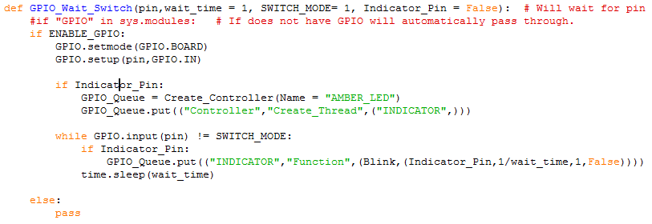
The GPIO wait switch procedure is used as a simple way to allow a system to wait for a specific GPIO pin switch to be in a specific state. This requires the number of the pin, the time between polls and the state in which the switch must be before the system accepts the input. Additionally if the Indicator_Pin is specified then the system will attempt to use as an indicator LED.
First the program checks if the ENABLE_GPIO flag is set to True, if not the program assumes it cannot complete the waiting using the GPIO pin successfully (assumes on platform which does not support the GPIO feature) and passes ( else statement there to allow later addition of display message that feature was not present if needed). Should the flag be enabled the GPIO mode is setup and the input pin configured, then if the indicator pin variable is used the Thread_Controller for the Indicator pin is setup with the name AMBER_LED and the thread created with name INDICATOR. The program then enters a while loop until the input on the input pin is set to the SWITCH_MODE variable. In the while loop the program will set the indicator LED to blink at 1/(Wait_Time) Hz for one cycle , such at the blink system will disable itself every loop cycle , therefore if the switch is set to SWITCH MODE the indicator LED does not have to be disabled and the pattern will be close to indistinguishable from continuous blinking. Finally the loop will sleep for wait time, the loop repeating until the switch is in SWITCH_MODE , at that point the procedure will end.

GPIO_Thread
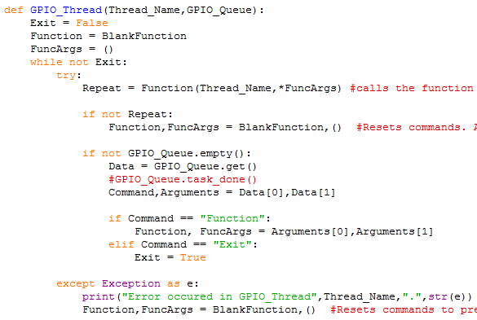
The GPIO Thread procedure is a generic function which can be used in a thread controller thread. The procedure essentially acts as a host for a number of subroutines which are passed in via the GPIO_Queue, running each subroutine with the required arguments until completion , checking for new instructions and continuing. The program loops in a while loop until an exit command is received. The program takes two variables, the Thread_Name of the thread and the GPIO_Queue queue.
First the Exit variable is set to False, function is set to BlankFunction ( a function which does nothing but wait 0.2 seconds each time it is called) and the function arguments are set to an empty tuple. The program loops until exit is set to false.
The entire loop contents are wrapped in a try/except statement which is designed to capture any errors, displaying the error message and resetting the functions and arguments to default, preventing the error from occurring repeatedly.
The current function is called with the Thread_Name as one argument and the expanded FuncArgs variable as the other arguments, once the function has completed execution the function should return a boolean variable stored in Repeat, this signals if the function should repeat automatically or should be cancelled. If the function should not repeat the functions are reset to the blank functions.
The program then checks if a new command is in the GPIO_Queue, if so the command and arguments are extracted. The program then checks if the command instructs the program to add a new function, in which case the function and it’s arguments are extracted, or to exit, in which case the exit flag is set to True and the program will exit.
This program is used to run the LED programs for the Drone_Logic in a simple manner, allowing new functions on a specific thread to overwrite others, preventing merging of LED commands ( eg blink and pattern would end up with an odd result).

Thread_Handle
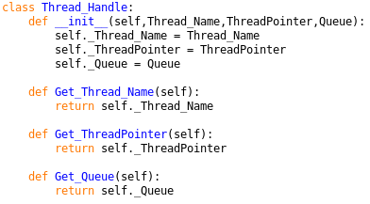
The Thread Handle object is an object used to manage the components required to manage a thread. This includes the Thread_Name, the Thread_Pointer (the object which links to the thread , used to close the thread) and the Queue used to communicate with the thread. The object takes these values as parameters when instanciated. The methods Get_Thread_Name, Get_ThreadPointer and Get_Queue will return the relevant information.

Thread_Controller
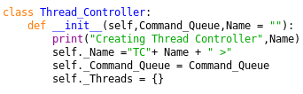
The Thread_Controller object is used to manage large numbers of threads via a command queue, without requiring the storage of queues and thread objects in lists which would need to be passed around the program. The Thread_Controller allows the sending of commands to the threads via the command queue, organises the threads by a Thread_Name and allows reseting of all threads at once if needed. The program also can propagate messages to the threads i.e. sending an exit message to all the threads at once when the thread controller should be reset. The thread controller offers two main modes when creating a thread, threading or multiprocessing, the former being more memory efficient while the latter allows the system to bypass the Global Interpreter Lock (GIL) which normally prevents usage of more than 1 CPU core by a single python program. The Thread_Controller itself is run in a seperate thread or process , allowing the main thread to continue to function independantly of the Thread_Controller.
Note: In most cases process and thread can be used interchangably and meerly differ in their resource requirements there are differences I.e requiring different queue types. Additionally the program allows launching of functions requiring arguments , these are given via a tuple which is expanded into the arguments of the function (indicated by the * in front of a variable).

When setup the Thread_Controller requires 1 parameter Command_Queue , a queue object from which it recieves it’s commands and optionally the Name parameter which is used by the controller when it prints statements in order to simplify outputs by multiple threads I.e the name allows an observer to identify which thread controller is performing which operation. The Name is set and the command queue set as an attribute. The Threads dictionary is created, it is used to store the thread handles for each thread , identifying them using the thread name as the key.

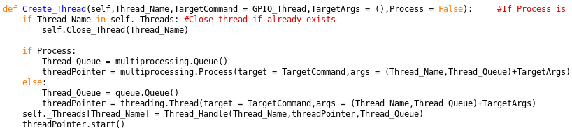
The Create_Thread method is used internally by the thread_controller to create new threads when requested. The method creates a new thread using the passed parameters and adds it to the threads list. The method takes one required parameter Thread_Name for the name of the thread ( what the thread will be referenced by by all users of the command queue). The optional parameter TargetCommand defines the function which the thread will run and per default this is GPIO_Thread, the TargetArgs is used to pass this function any arguments required. The Process Value is used to set if the new thread will be a process or a thread.
First the program checks if the thread name already is in use, if so the old thread is closed in order to prevent the abandoned thread eventually not exiting, causing a memory leak. Then the Thread_Pointer and Queue objects are created , using multiprocessing settings if the process flag is set to True and threading settings if the process flag is false ( processes required a different type of queue to communicate and must be created using the multiprocessing.Process object). The created Queue and threadPointer objects are then used to create a thread handle object, which is then placed in the dictionary using the thread name as a key. Finally the thread is started.

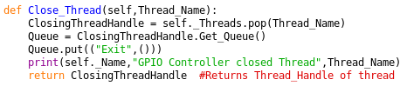
The Close_Thread method is used to close a thread with the given Thread_Name. The thread handle for the thread is removed from the Threads dictionary and the queue is obtained from this object. The Exit command is sent to the thread , a closing message is displayed and the handle returned in case it is required elsewhere.

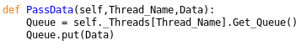
The PassData method is used to pass a data package to a thread. This requires the Thread_Name and Data package. The Queue for the thread is obtained and the data placed in the queue.

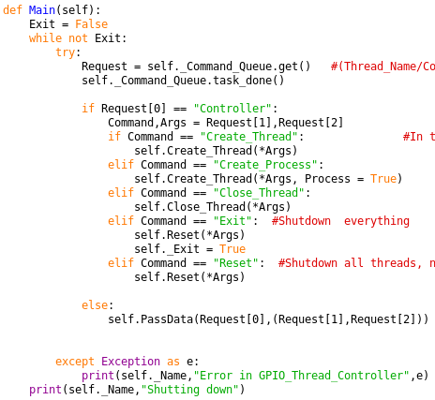
The Main method runs the main loop for the thread controller. The Thread_Controller continously checks for new instructions and executes them in a loop until Exit == True. The entire system is contained within a try/except statement, designed to catch errors so that the Thread_Controller can continue to function even if an instruction was incorrect, otherwise the Thread_Controller threads would be stuck without a method to contact them. The program obtains an item from the Command_Queue, waiting until one arrives if necessary and marks the task as done ( not strictly necessary). The program then checks if the target is for the Controller or a sub thread, if for the sub thread ( name is not controller) then the data package is sent to the sub thread via the PassData argument.
Should the data be fore the controller the Command and arguments are extracted from the data. The Command is then compared to the commands allowed and the relevant command is executed, the arguments being expanded and passed to the function.
Create_Thread – Create a new thread
Create_Process – Create a new process
Close_Thread – Close the thread
Exit – Close all threads and exit controller
Reset – Close all threads but do not exit

Should an exception have occurred then the exception will be caught in the except statement, the error will be displayed with the Thread_Controllers name.
When shutting down the shutting down message is displayed.

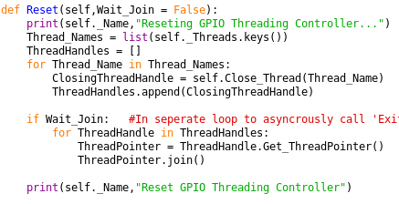
The Reset method is used to reset the controller by closing all sub threads. The optional parameter Wait_Join is used to signal if the program should wait for all the threads to join before continuing or not. When using processes it is a recommended convention to join the process once completed, allowing the sub process to close correctly and preventing the sub process from remaining alive without work to do causing a memory leak. However it seems on many systems that this joining functionality is not required ( Rasberian and Lubuntu) and that the processes close without the join functionality, therefore the wait to join system is optional.
The program displays that the Thread_Controller will be reset. All of the Thread_Names are obtained and stored in a list, a new list is created to store the Thread_Handles. The program then loops through each Thread_Name in the Thread_Names and closes the thread and adds the handle to the ThreadHandles. The use of the Thread_Names rather than looping through the dictionary is used as the threads are removed from the dictionary during the loop which could otherwise result in unexpected behaviour.
Should the Wait_Join flag be True then the program will loop through each Thread Handle, obtain the thread pointer and wait for the thread to join. This may take some time , depending on the amount of time the sub threads require to respond to the exit command.

Create_Controller
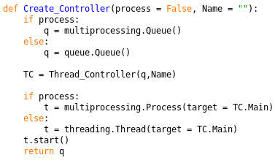
The Create_Controller function is a convienient way to create Thread_Controllers either on a thread or seperate process. The function takes two optional arguments, process which sets if the Thread_Controller should be in a new process or not and Name which controls what the name of the Thread_Controller should be. Generally placing the Thread_Controller in the same thread is a better idea as it will not require a large amount of computing power, however the option is available if the Thread_Controller should be changed such that it could adversly affect the performance of the main thread.

The queues are created depending on the value of the process flag. The Thread_Controller is instanciated with the queue and the Name variables and the thread is created depending on the value of the process flag. The thread is started and the queue is returned.

GPIO functions
These functions/procedures can be used by the GPIO thread component in order blink, display patterns etc. The function does not need to use GPIO, the GPIO thread is just a convienient host to manage the functions. The general pattern is as follows if placed in the GPIO_Thread:

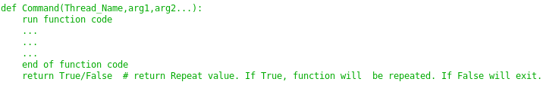
The command must take the Thread_Name as an argument, it may optionally take more arguments passed via the FuncArgs variable. The code may run, however it should eventually complete such that the thread is not permantly blocked ( more convinient, not necessary). The program should then return True or False variable depending on if the function should be repeated if no new function is found. I.e If the program returns True the program will repeat if no new function replaces it, if False then the program will be replaced with the blank function.

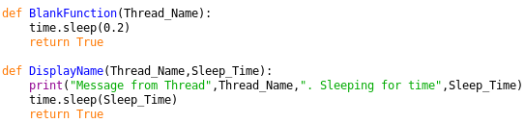
The BlankFunction is used as place holder, it sleeps for 0.2 seconds and returns True.

The DisplayName function will print the Threads name and sleep for the given amount of time and repeat.

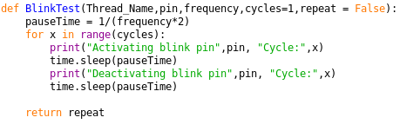
The BlinkTest method is used to imitate an LED. The function takes the pin, frequency , number of cycles for which it should repeat before completing and if it should repeat. The pauseTime is calculated for the half the time period of the frequency. The program then loops through , enabling and disabling in a simulation by printing the state and cycle, then waiting for the time period to complete. The program then returns the repeat value.

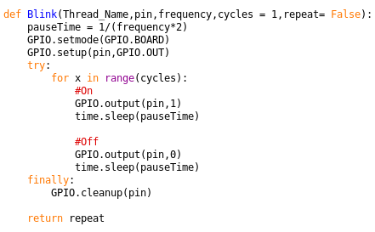
The blink function acts similarly to BlinkTest, however this version uses an LED. The function takes the pin, frequency , number of cycles for which it should repeat before completing and if it should repeat. The pauseTime is calculated for the half the time period of the frequency. The GPIO mode is setup and the pin set to output. The program then attempts to enable and disable the LED for the given number of cycles, sleeping between switches. If an exception occurs it will be caught by the try/finally statement, in either case the GPIO cleanup procedure will be run on the pin. Finally the return value is returned.

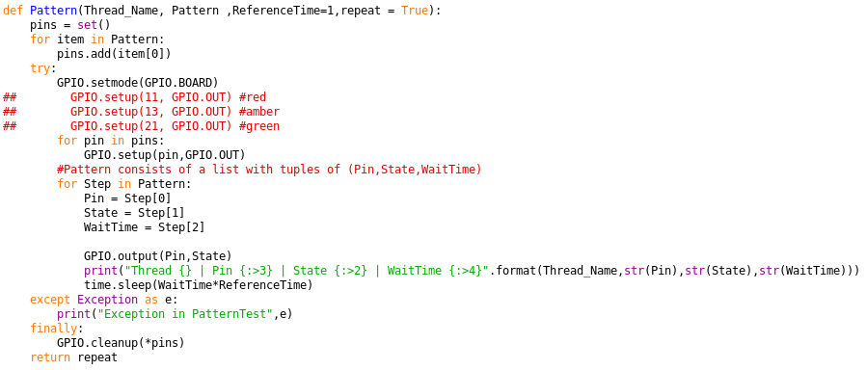
The pattern method is used to display patterns using a list containing the pattern information. The function takes the Thread_Name, Pattern list , optional ReferenceTime and repeat flag. A set is created to store all the pins used. All the pins in the Pattern are added. The program then enters a try/except/finally statement. The GPIO mode is set and each of the pins are set to the output mode. For each set in the pattern the program obtains the pin, state and wait time , sets the pin to the desired state, displays the relevant values Thread_Name, pin, state and wait time to the observer ( can be used to check the pattern is functioning as intended), and sleeps for the wait time value. This system enables patterns to be displayed using this method which would be rather complicated to setup otherwise. Should an exception occur it will be caught and the exception displayed to the observer. Finally all the pins will be cleaned by the GPIO cleanup procedure and the repeat value will be returned.

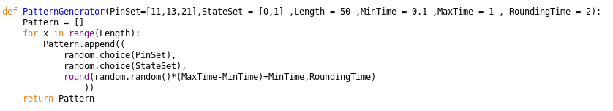
The pattern generator function is used to randomly generate patterns ( mainly to test the pattern system). The program takes the allowable pin set, state set, maximum length, minimum sleep time, maximum sleep time and the number of decimal places the times should be rounded to.
An empty pattern list is created. The program then loops through for length number of iterations , randomly adding tuples containing a random pin, state and sleep time rounded to the RoundingTime number of decimal places. The pattern is then returned.

